QGIS Software and Draw My CA Plugin Installation
A Brief Overview
The Draw My CA Installer bundles the installation of QGIS 3.16.4 and Draw My CA QGIS plugin, so you will not need to install QGIS separately. Once the installation process is finished, the Draw My CA installer will copy the plugin into the QGIS 3 plugin folder. In this document, we will refer to the plugin folder as swdbqgis-X.X.X-X.
Pre-Installation Notes
If QGIS is already installed on your computer and you want to use an account that does not have administrative permissions, you must first log in to your operating system as the admin and give the account you’d like to use write permissions to the QGIS folder.

If QGIS is not already installed on your computer, follow the installation instructions below and give all the users (accounts) who will be using QGIS permission to use the QGIS application.
If you are using the administrator account you don’t have to do anything - just follow the instructions below.

Table of Contents
Downloading QGIS 2
Installing QGIS 7
Creating a Redistricting Group Account 11
Uninstall software 17
More Info: Folder location and environment of the software 18

Downloading QGIS

- Before you begin, please make sure that you have at least 5 GB of space in your hard drive.
- One gigabyte for swdbqgis-X.X.X-X.zip file. You can remove this file once you are finished with the installation process.
- One gigabyte for extracting the swdbqgis-X.X.X-X.zip file. You can remove this file once you are finished with the installation process.
- Two gigabytes once the installation process finishes.
- Reserve one gigabyte to start your first project

- Open your favorite browser, input URL https://www.redistrictinggroup.org/installer/ into the address bar and click on swdbqgis-1.0.0-8.zip

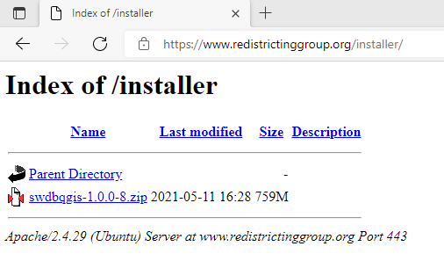
- Download the ‘swdbqgis-1.0.0-8.zip’ file

- Open File Explorer and navigate to your Downloads folder. Right click on the downloaded file and select Extract All.

- The extract folder is the location of your swdbqgis.X.X.X-X.zip file. Click Extract.

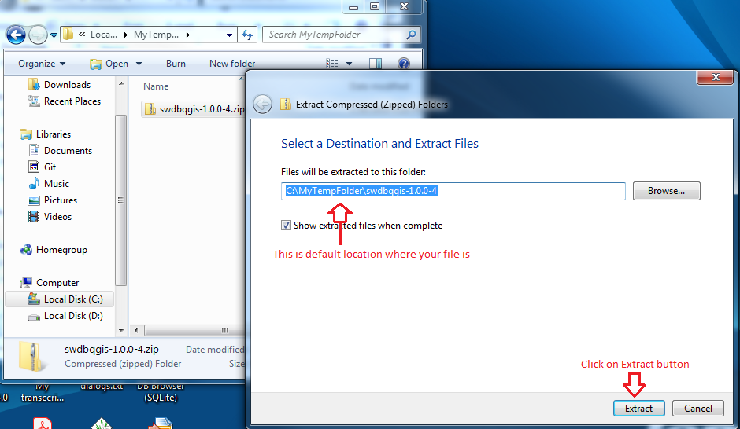

- QGIS 3.16 requires administrator privilege during the install of the software only. Also, some antivirus software may complain about running Windows batch file (.BAT) and/or executable file (.EXE). If you encounter an issue, you may have to disable your antivirus and turn it back on once the installation process is finished. To install or uninstall the software, double click on swdbqgis-X.X.X-X folder to navigate until you see the files and double click on SETUP-X.X.X-X file.

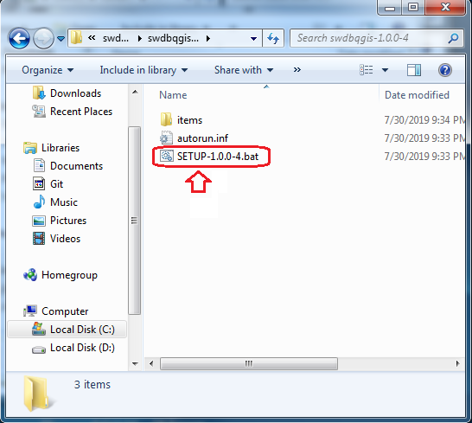
- The Windows will display User Account Control dialog and ask you to click Yes or No button. Click Yes. The image below is an example of User Account Control and each version of Window may show this differently.

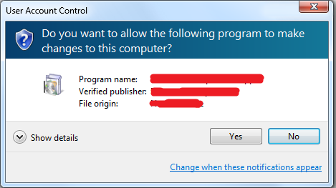

Installing QGIS
After you have completed each step in the section above, move on to the installation of the QGIS software outlined in this section.

- Click the Next button.

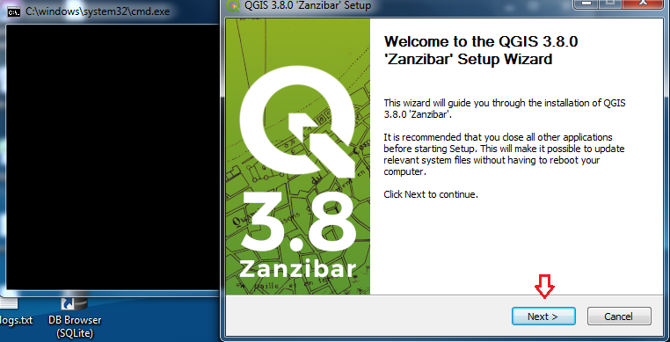

- Click on I Agree.

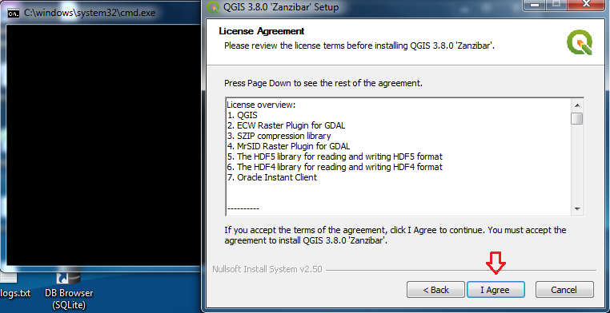

- Select the Destination Folder to install the software or just click the Next button.

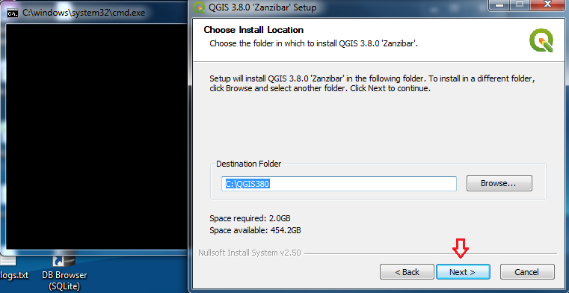

- Click Install to begin the installation of the QGIS software.

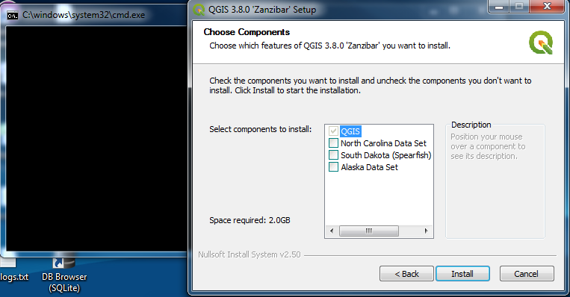

- The QGIS installer will copy the files into your computer, as seen below:

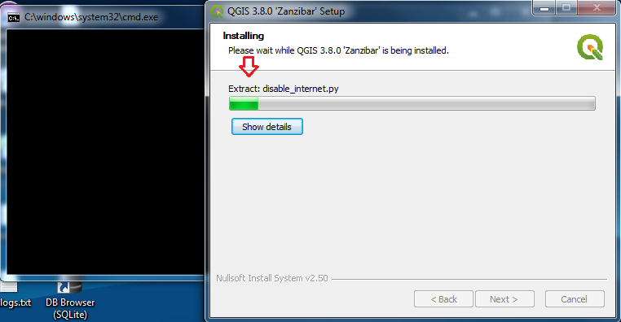
- Click the Finish button. QGIS has now been successfully installed on your system, but the Draw My CA Installer still needs to copy the Draw My CA plugin to your profile folder.

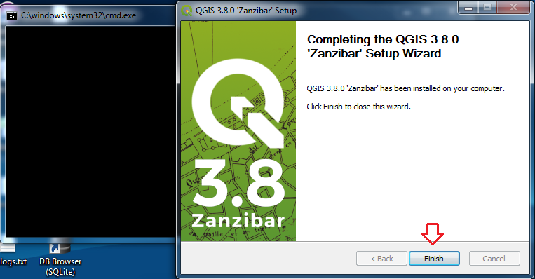

- The screen below shows that the SWDB Installer copied the Draw My CA plugin into the destination folder. The progress bar is moving and the button is grayed out.

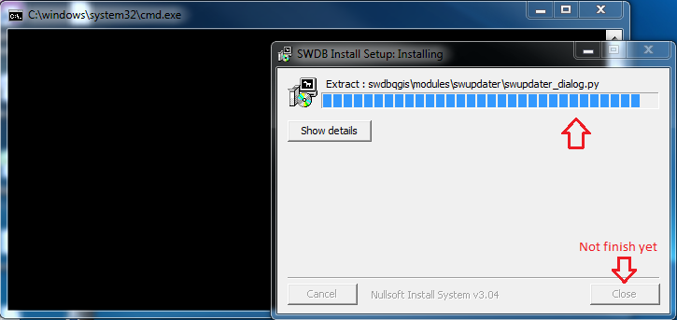
- Click the Close button to finish the process once it has completed.

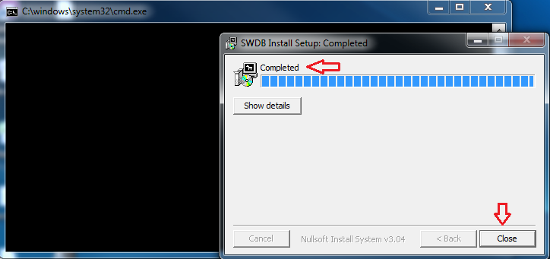

Creating a Redistricting Group Account
QGIS will display dialogs to help you create your first project. Follow the steps in this section to create your account.
- Upon opening QGIS, the User Connect dialogue box will display as seen below.

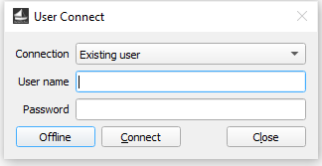

- Assuming you do not have an account, select the ‘New user?’ option. 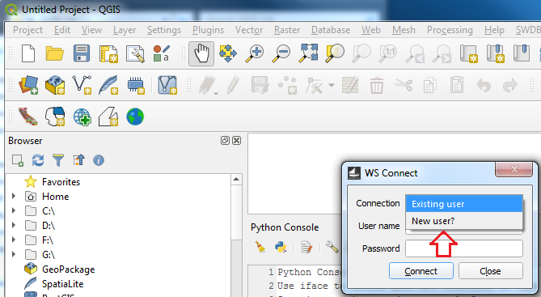

- The ‘New user?’ option will launch your browser and open the REDISTRICTING GROUP web page. Click the Register link to register a new account.

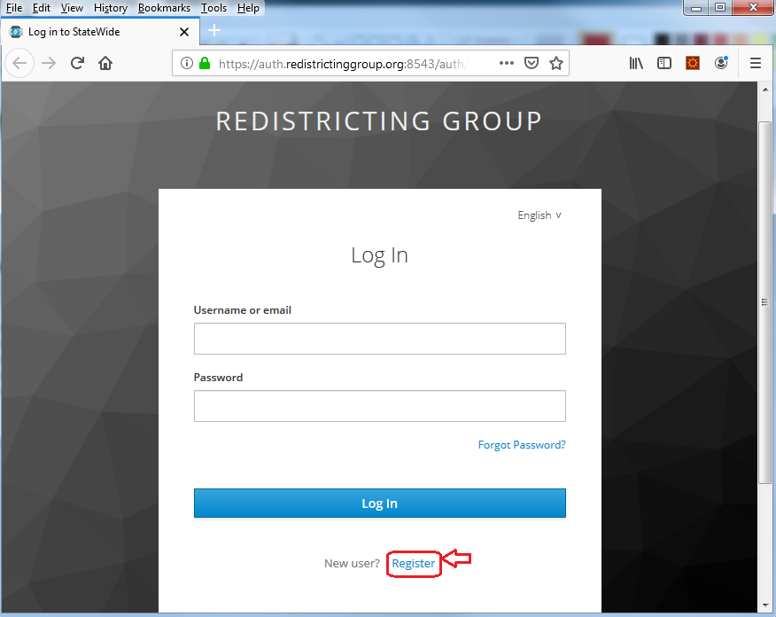
- Fill in all the required information and click on the Register button.

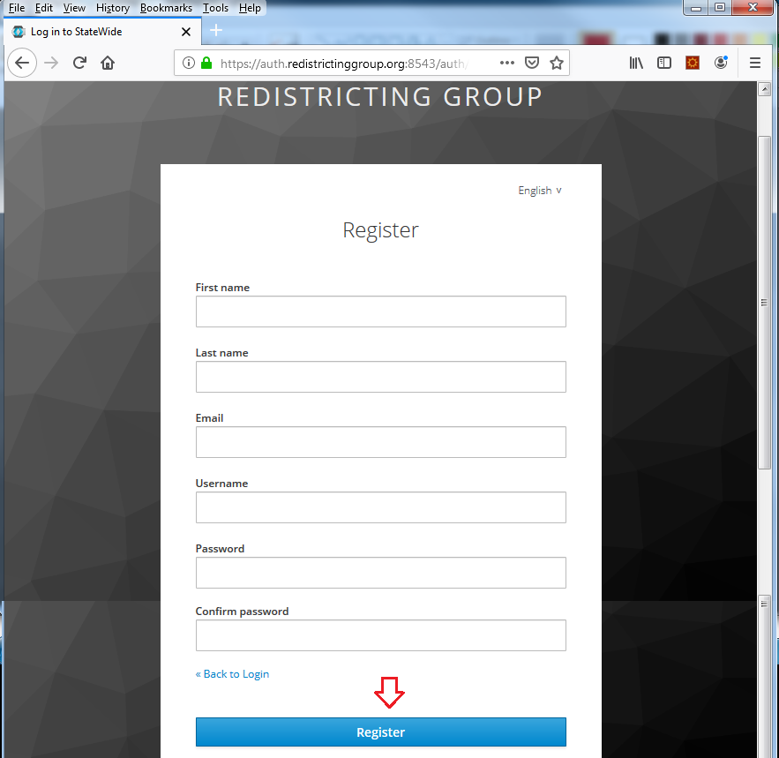
- Once you have registered your account, you may select the "Existing user" option, input username, password and click Connect button.

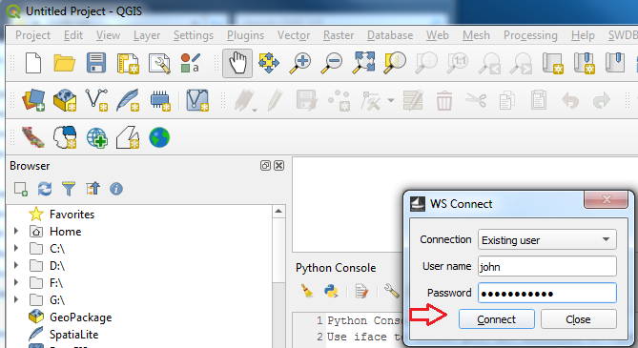
- After logging in with your credentials, the program will open the Plan Management dialog box, and you can begin to create your project.

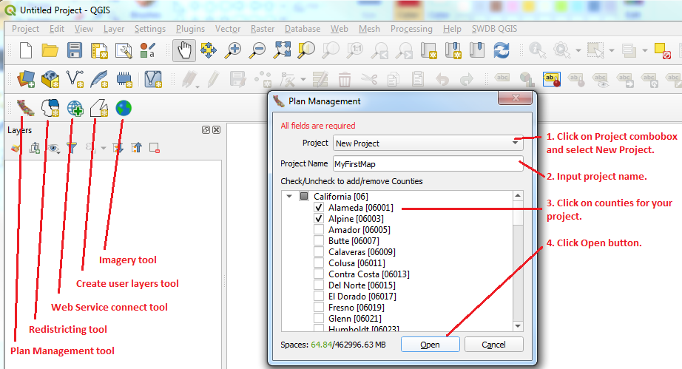

Note: If this is your first time creating a new project using the plugin, please first load the entire state of California by checking the box next to California at the top of the county list (see below). This will take about 10-15 minutes to load, so please be patient. Doing so allows for the entire state’s data to download onto your computer, and will result in much quicker load times for each ensuing project you create.

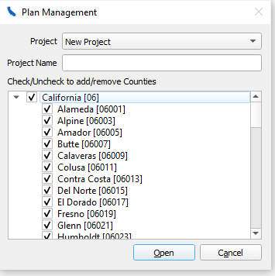

After you successfully create a project with the entire state loaded, restart QGIS, and log back in with your credentials. You are now ready to create your first project.

Creating a New Project

- Open QGIS and login with your credentials. The program will create a project under folder <Window User Profile folder>\SWDBQGIS. If you use the Windows Explorer tool and navigate, then you will see your project information.
- After logging in, the Plan Management window will display:

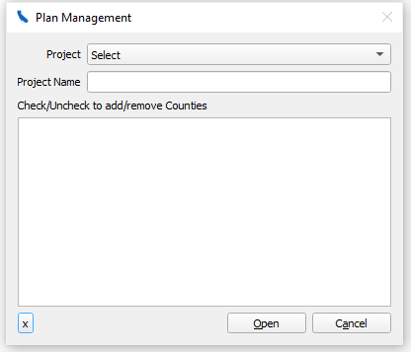

- In the ‘Project’ dropdown, select ‘New Project’. Next, type in a Project Name of your choice. Then, select the check-box of which county or counties you would like to work with.

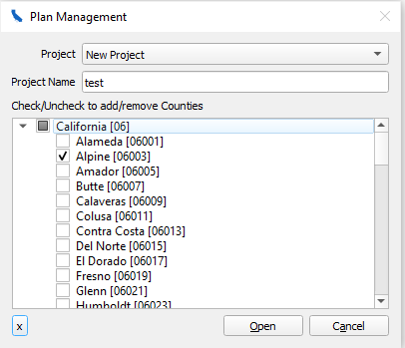

- Lastly, the project will display in QGIS. You should see the county or counties you selected in step 3.

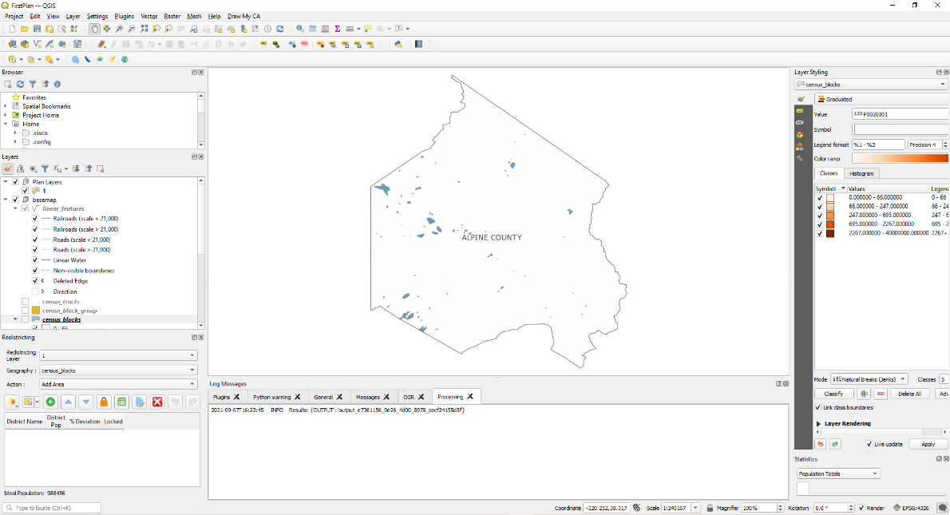

Uninstall software
Refer to Download the file section for SETUUP-x.x.x-4.bat. You can double click on the file and the Draw My CA Installer will check if you have QGIS 3.16.4 installed on your system. Then it will ask you to uninstall and once uninstall is successful, Draw My CA will ask you to install the software again. Click the Cancel button.

More Info: Folder location and environment of the software
Section Overview
- The QGIS binary software is in C:\QGIS380
- The profile-path is under <Window User profile>\QGISSWDB\
- Draw My CA plugin folder is under <Window User profile>\QGISSWDB\profiles\default\python\plugins\swdbqgis
- Draw My CA data is under <Window User profile>\SWDBQGIS\

Note: The information below is only important if you want to keep your QGIS separate from Draw My CA or you already have QGIS installed on your system. If you do not use Draw My CA Installer, the folder, location and environment will different.

- You can find the destination of the QGIS software folder at C:\QGIS3164.
- Once you have installed QGIS, it will create a QGIS 3.16 folder on your desktop and Windows Start button.
- Double click on QGIS 3.16 desktop folder and right click on QGIS Desktop 3.16.4 and go to Properties.
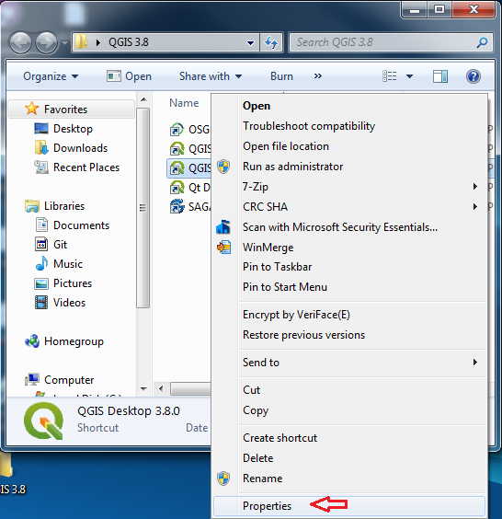
- Once in Properties, click on the tab labeled “Shortcut”
- Once there you will see the Target text box. The default file path is determined by the
- Draw My CA plugin the profile-path under --profiles <Window User
- profile>\QGISSWDB\. The idea behind the scene is to separate the environment from your other QGIS workspace.

Example: C:\QGIS380\bin\qgis-bin.exe --profiles-path C:\Users\joe\QGISSWDB\
- C:\QGIS380 is the QGIS software folder.
- C:\Users\joe\ QGISSWDB\ is the Windows User Profile folder with QGISSWDB.
Note: The QGIS default location is under <Windows User Profile>\AppData\Roaming\QGIS. If you compare between QGISSWDB and QGIS 3 default location without running QGIS 3 yet, the number of files will be different. Please do not modify the files, since those files are the minimum requirement for Draw My CA to startup and properly set up the environment.

Note: Upon the first time opening the QGIS Desktop 3.16.4 executable, QGIS will create necessary files under --profile-path folder. After this is complete, the Draw My CA plugin dialog will display automatically.

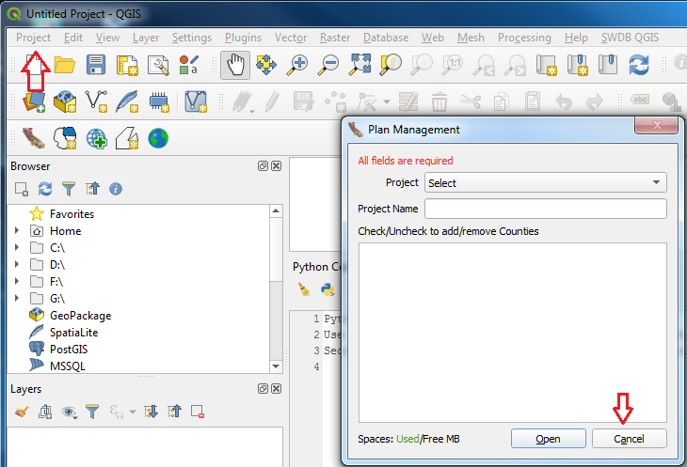

- Click the Cancel button and Project menu bar Exit QGIS.

In Summary:
Use Windows File Explorer and navigate to <Window User Profile>\SWDBQGIS. This is the location for the Draw My CA plugin data only.
- logs folder contains files of your activities each day (no sensitive information). This information is important only if you have errors. You can remove the old files if you need your hard disk space but please make sure that QGIS is not open.

- GeoData folder contains base map shapefile. If the county that you selected on the Plan Management dialog does not exist then the program will download data and save it into this folder.

- swdbdata folder contains all the work based on the project name.

- temp folder contains temporary data that is used during the runtime process. The file or folder will be removed once the program finishes the task. Please make sure that you do not open QGIS, if you want to remove it.

